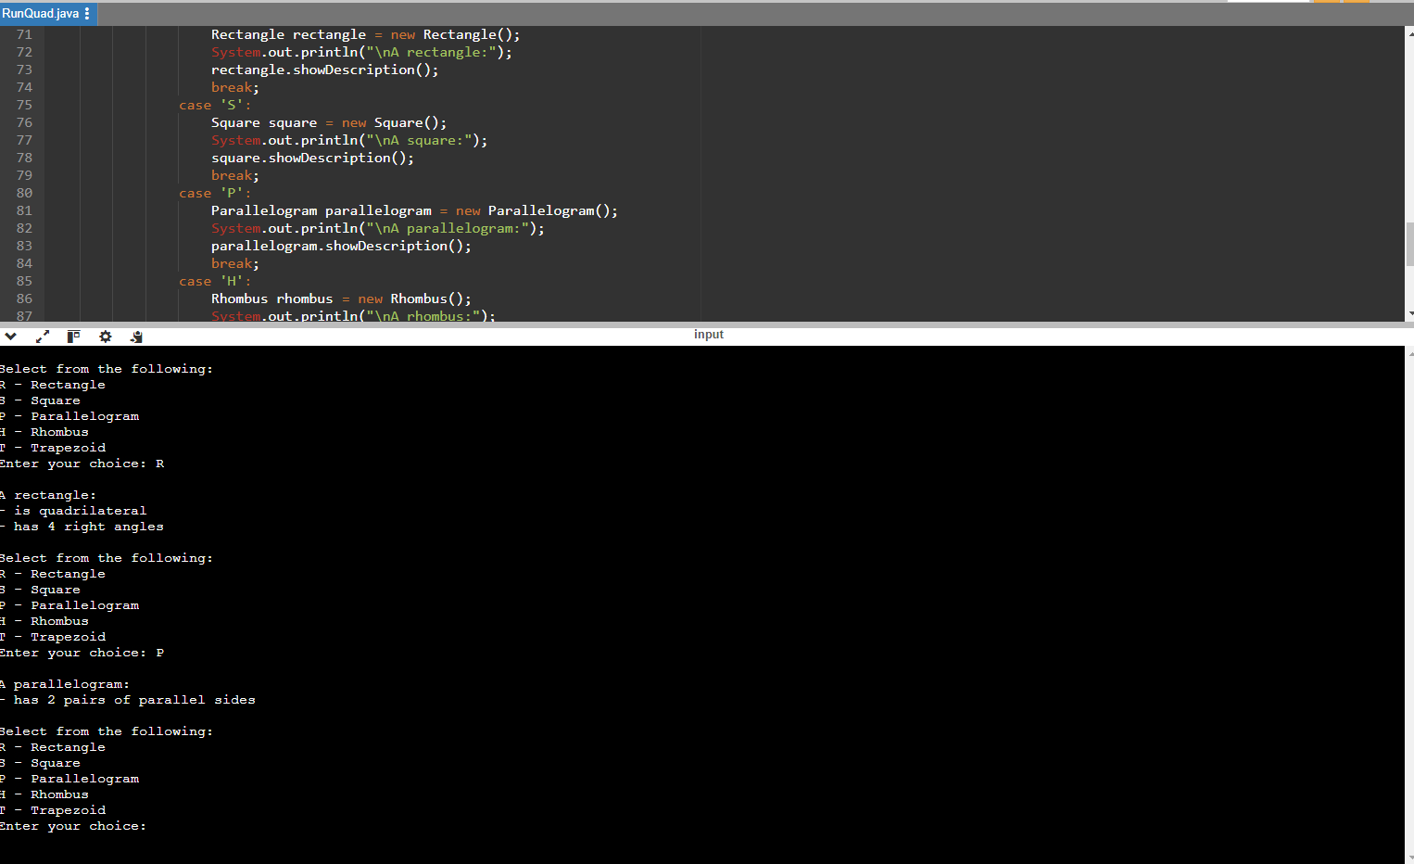

import java.util.Scanner;

// Base Class: Quadrilateral
class Quadrilateral {
public void showDescription() {
System.out.println("- is quadrilateral");
}
}

// Rectangle class inherits from Quadrilateral
class Rectangle extends Quadrilateral {
@Override
public void showDescription() {
super.showDescription();
System.out.println("- has 4 right angles");
}
}

// Square class inherits from Rectangle
class Square extends Rectangle {
@Override
public void showDescription() {
super.showDescription();
System.out.println("- has 4 equal sides");
}
}

// Parallelogram class inherits from Quadrilateral
class Parallelogram extends Quadrilateral {
@Override
public void showDescription() {
System.out.println("- has 2 pairs of parallel sides");
}
}

// Rhombus class inherits from Parallelogram
class Rhombus extends Parallelogram {
@Override
public void showDescription() {
super.showDescription();
System.out.println("- has 4 congruent sides");
}
}

// Trapezoid class inherits from Quadrilateral
class Trapezoid extends Quadrilateral {
@Override
public void showDescription() {
System.out.println("- has 1 pair of parallel sides");
}
}

// Main Class
public class RunQuad {
public static void main(String[] args) {
Scanner scanner = new Scanner(System.in);
char choice;
do {
System.out.println("\nSelect from the following:");
System.out.println("R - Rectangle");
System.out.println("S - Square");
System.out.println("P - Parallelogram");
System.out.println("H - Rhombus");
System.out.println("T - Trapezoid");
System.out.print("Enter your choice: ");

choice = scanner.next().toUpperCase().charAt(0);

switch (choice) {
case 'R':
Rectangle rectangle = new Rectangle();
System.out.println("\nA rectangle:");
rectangle.showDescription();
break;
case 'S':
Square square = new Square();
System.out.println("\nA square:");
square.showDescription();
break;
case 'P':
Parallelogram parallelogram = new Parallelogram();
System.out.println("\nA parallelogram:");
parallelogram.showDescription();
break;
case 'H':
Rhombus rhombus = new Rhombus();
System.out.println("\nA rhombus:");
rhombus.showDescription();
break;
case 'T':
Trapezoid trapezoid = new Trapezoid();
System.out.println("\nA trapezoid:");
trapezoid.showDescription();
break;
default:
System.out.println("Invalid choice! Please try again.");
}
} while (choice != 'X'); // Exit condition
scanner.close();
}
}

.

